**Installing Knausj**

We must install Knausj before even beginning to work with Talon. The first step is to go to:

( <https://github.com/knausj85/knausj_talon> )

And install the zip folder by following the image below

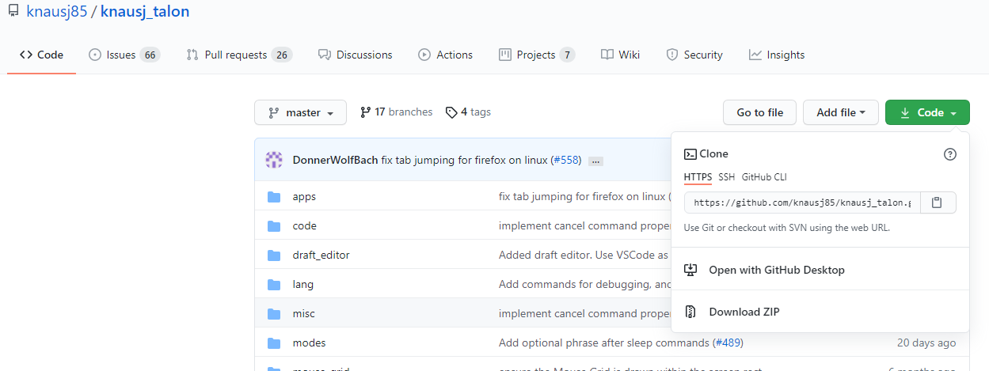

You can then open talon/user by clicking the bottom right of the screen and opening like the image below

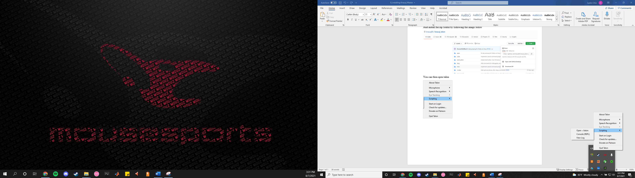

From there, paste the Knausj folder from the zip file into the user folder like the image below

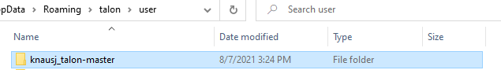

You will do the same thing and download the w2 folder from the learn tab of the Talon website and replace the w2l folder in your folder with the newly downloaded one.

From there, you’re good to go to start coding. I suggest that you test out the commands by stating outloud “help active” which will give a list of commands currently accessible to you. “help alphabet” will also allow you to see which words correspond to which letters of the alphabet.